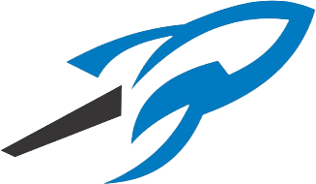
Rockvale Youth Football and Cheerleading
Sponsorship and Donations

Grey Sponsor - $200
- Company Name and Logo on website and social media
- Will Receive Team T shirt
Black Sponsor - $400
- Company Name Logo on Website and social media
- League Thank You Gift
- Will Receive Team Shirt and Team Hat
Blue Sponsor - $600
- Company Name Logo on Website and social media
- League Thank You Gift
- Banner on the fence during ALL home Games (Banner Paid for by RYFC)
- Will Receive Team Shirt, Hat and Hoodie
MVP Rocket Sponsor - $1,000
- Company Name Logo on Website and social media
- League Thank You Gift
- Banner on the fence during ALL home Games (Banner Paid for by RYFC)
- (optional) Booth set up in a high Traffic Area on a game day of your choice, if power is needed, please give us notice.
- Will Receive Coaches Package (Sublimated WHITE Coaches Shirt with Sponsor on the Front, Team Hat, and Team T-Shirt) and Hoodie

Please return 3310 Middleton dr. Rockvale TN 37153
Send logo to rockvaleyfc@gmail.com

Company Name: _______________________ Donation: _______________________
Representative Name: _____________________ Rep. Number: _______________________
Name on Sign Sign: ______________________________________________________________
Shirt Size: _________________ Hat Size: S/M M/L L/XL
Name on Shirt if MVP Rep: _______________________________________________________

